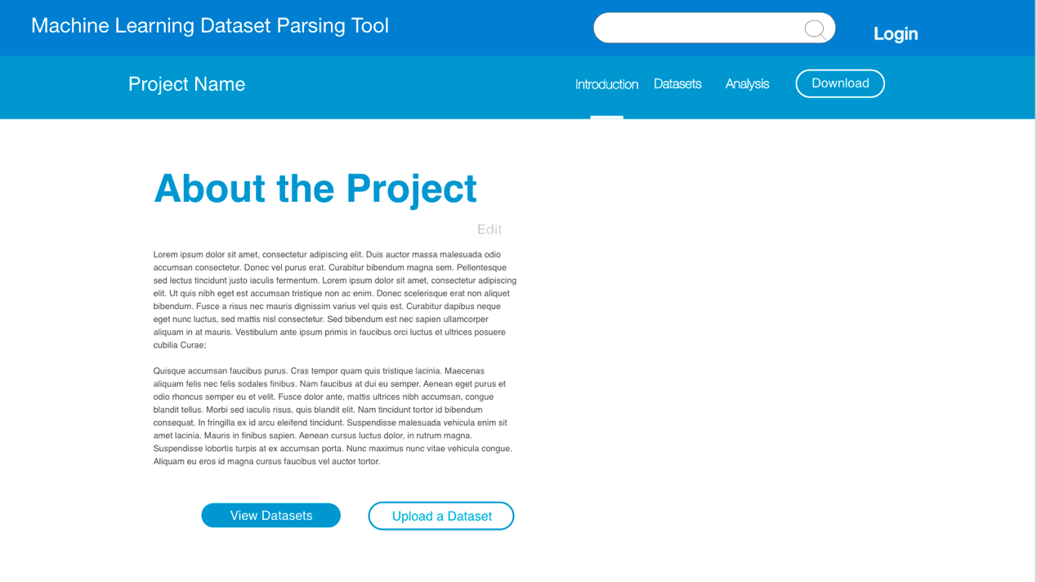

The user interface prototype is designed for our project machine learning dataset parsing tool according to the user requirements. For the functionalities part, there are home (Machine learning dataset parsing tool), search engine and login buttons in the first line. For the first users, they need account to log in to keep private when they upload files. When users click on button home, a brief description will show to users and it can return to the main page that contains several projects recommended when users click on it. The search engine is used to search projects of datasets. Secondly, there are projects name, introduction, datasets, analysis and download in the second line. When users click on introduction, datasets and analysis buttons, it will jump to a new page. The first two lines will show in each page. In the several medium lines, the first page is an introduction about the project. In the end line, there are two buttons view datasets and upload a dataset for users to deal with the datasets.

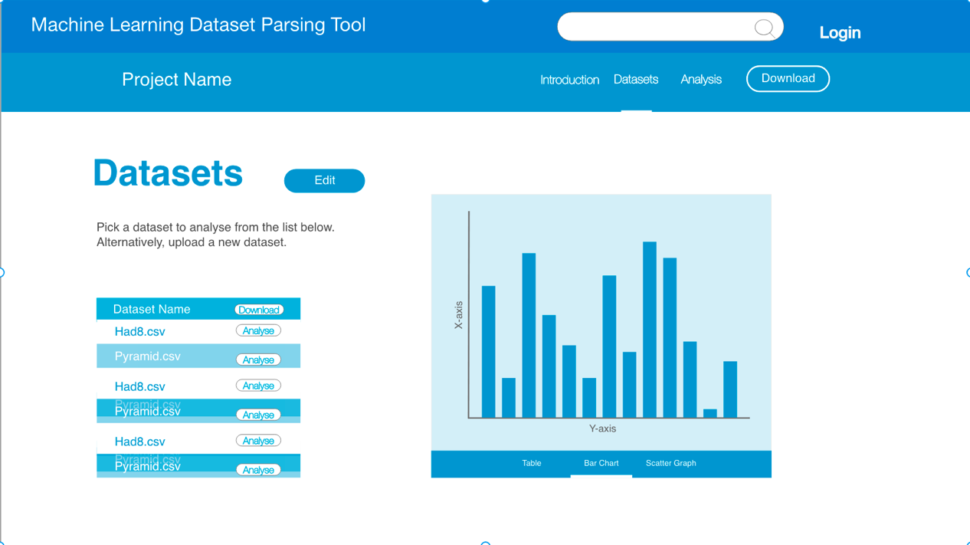

The second page is dataset list. In the left part of the page, all csv files including in the dataset list can be chosen to show the data graphs. The button edit is designed for users to upload and delete other csv files. The button download is for users to download the files they need. The button analyze is showing results for each file. As for dataset part can directly show those files by using table, bar chart, scatter graph and so on which will depend on the contents of the data.

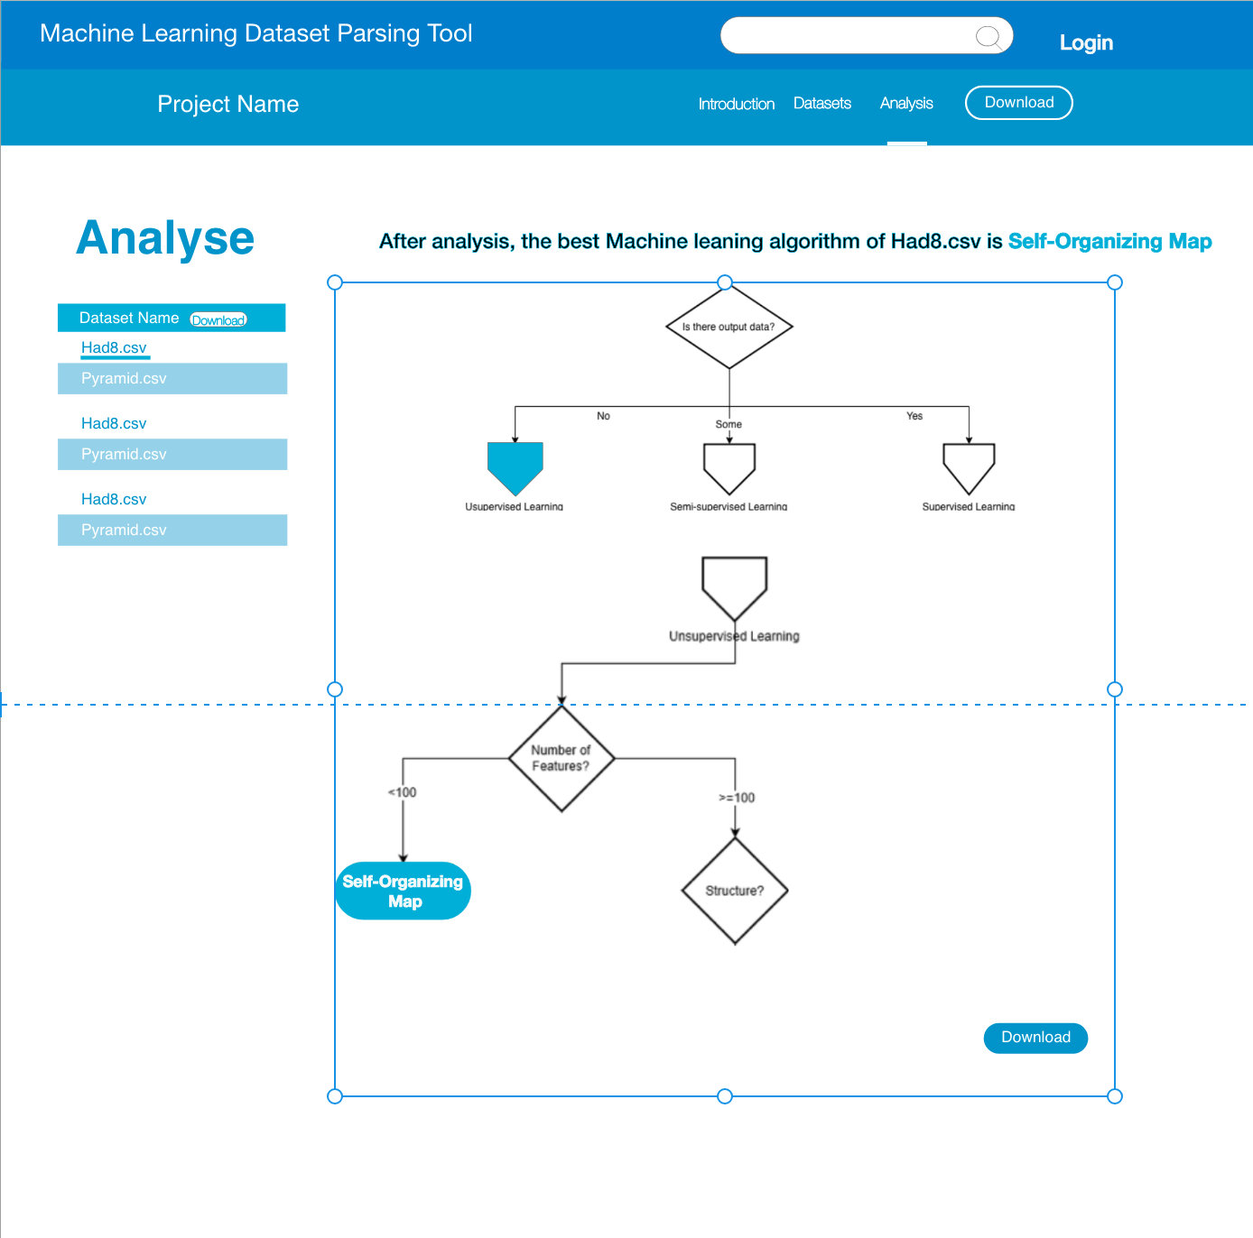

The third page is analysis part, in which users can find out which algorithm should be chosen to perform machine learning in the right part. The analysis result is shown in the top for user quickly knowing the result. The flow part is decision tree to explain why the algorithm is chosen. And, in the bottom of the decision tree, there is a download button, which is used for download the picture of the decision tree. These functionalities are adjustable for use as both a prefilter for machine learning and as a teaching aid which can contribute to users to learn how to analyze the datasets.